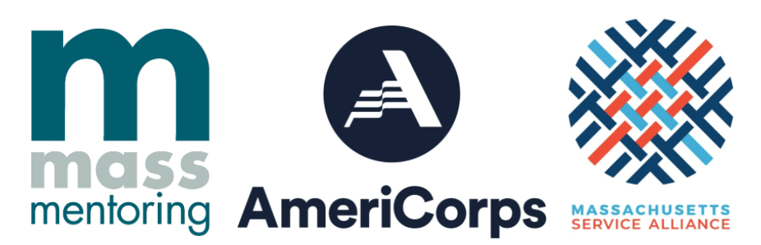

AmeriCorps Ambassador of Mentoring
Mass Mentoring Partnership AmeriCorps Ambassadors of Mentoring supports mentoring because every young person in Massachusetts deserves access to quality mentoring relationships - regardless of who they are and where they live. AOMs serve youth serving organizations across the state by strengthening mentor recruitment, matching and training; establishing community partnerships; coordinating marketing campaigns; and improving program design.

MA will have a vibrant and active network of mentoring and youth serving providers sharing best practices and raising their voice to advocate for youth. MMP serves more than 370 programs statewide, supporting over 30,000 youth in quality relationships.

Position Description:
Boston Day and Evening Academy (BDEA) is seeking an extraordinary Mentoring Coordinator excited to be a part of a BDEA program- BDEA 2.0- designed specifically for young men of color who have been underserved/discouraged in traditional schools, and who are disenfranchised from even the possibility of graduation. BDEA is an innovative public high school whose mission is to serve students who are overage for grade level, all of whom have experienced interruptions to their education.

We are looking for a Mentoring Coordinator eager to challenge the norm, to assist a committed team in building a new pathway for the city’s most marginalized students, and to embrace with us the following mission statement and core values:

BDEA 2.0 Mission Statement:
We are a student-led community. We collaborate to create meaningful learning experiences that give us the freedom to grow academically, develop agency, learn about ourselves, and acquire the skills to achieve our vision for the future.

Core Values:
In our community, consistently
- We have each other’s back
- We are authentic and open with each other
- We value transparency, integrity, and trust
- We demonstrate mutual respect
- We challenge mediocrity by setting high expectation for ourselves
- We honor self-growth and development
- We hold each other accountable
- We inspire and motivate each other
- We build responsibility and independence through collaboration and shared leadership
- We acknowledge the historical and present racial, cultural, and economic discrimination all around us, and we commit to leading change in creating equity.
- We help each other navigate and thrive in the world
- We promote versatility and adaptability

Project Responsibilities
- Participate in monthly corps-wide trainings and events
- Complete all required monthly AAoM documentation, including evaluation reports and timesheets
- Develop a new mentoring program by identifying an industry or passion connected mentor for up to 60 young men
- Leverage existing relationships with nonprofit and industry partners to cultivate a mentor database
- Meet with young adults to understand their passion and areas of support to ensure they are meeting with compatible mentors on a regular basis
- Assist BDEA 2.0 staff with the startup procedures for onboarding new mentors
- Hold bi-monthly mentor community meetings, inviting new mentors to these meetings to increase the circle of support
- Work with BDEA 2.0’s College and Career Pathway Coordinator to finalize handbooks, structures, and systems to optimize the procedural elements of this new program

Qualifications:
- Passion for working with diverse youth and families
- Strong critical thinking and problem solving skills
- Motivation and aptitude for networking and outreach
- Committed to actively recruiting, selecting, on-boarding and managing mentors
- Experience with and/or commitment to youth development
- Must be a U.S. citizen, national, or legal permanent resident alien
- Must be willing to undergo a National Service Criminal History Check, including screenings through the National Sex Offender Public Website, a name-based search of the statewide criminal history registry and a fingerprint based FBI check. *Eligibility to participate in the AAoM program is contingent on the results of this screening
- BA/BS strongly preferred or equivalent experience
- A passion for volunteerism and community service

Position Benefits
For an eleven month, full-time commitment and 1,700 hours of AmeriCorps service Fellows receive:
- Annual stipend of up to $15,100 (slightly more for a second year Father Monan Fellow position)
- Free health care coverage
- $6,195 Education Award, Loan deferment and interest accrual payment for qualifying loans upon completion of service
- Graduate certificate in Youth Development and Social Equity from Boston University
- 250+ hours of professional training and networking opportunities
- Travel expense reimbursement for qualifying travel expenses

To Apply:
If you are interested in applying please submit on our online portal here. More information about the program can be found online at www.massmentors.org/ambassadors including our full list of current open positions. Note that 1 application is required PER organization if you are applying to more than one.

All applications require a resume and cover letter stating how you heard about this opportunity and why you are interested in serving as an Ambassador, either in Word / PDF format and two (2) references.

MMP is committed to building a culturally diverse staff and strongly encourages applications from people with disabilities, men*, POC, and other underrepresented candidates. Note: Positions are contingent upon continued CNCS grant funding.
*”Men” is inclusive of ALL men

For more information or questions:
Contact, Rosie McMahan, AAoM Program Manager, at rmcmahan@massmentors.org

Mass Mentoring Partnership and its site partners are equal opportunity employers.
MMP makes reasonable accommodations for individuals with disabilities for interview as well as service term. MMP is committed to fighting racism and will continue to examine its practices and organizational culture in the process. MMP actively engages with the AmeriCorps members, host sites, and community partners to create a discourse that results in action when it comes to confronting racism.

