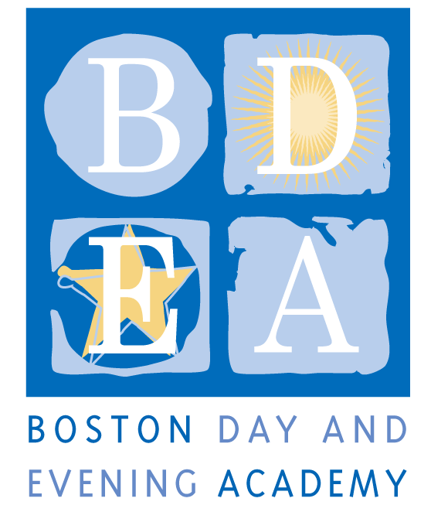
The Boston Day & Evening Academy 2.0
Horace Mann Charter School
Social Worker/Coordinator
School Year 2020-21

Boston Day and Evening Academy (BDEA) is seeking an extraordinary Social Worker/Coordinator excited to be a a part of a BDEA program- BDEA 2.0- designed specifically for young men of color who have been underserved/discouraged in traditional schools, and who are disenfranchised from even the possibility of graduation. BDEA is an innovative public high school whose mission is to serve students who are overage for grade level, all of whom have experienced interruptions to their education.

We are looking for educators eager to challenge the norm, to assist a committed team in building a new pathway for the city’s most marginalized students, and to embrace with us the following mission statement, core values and guiding principles for instruction.

BDEA 2.0 Mission Statement:
We are a student-led community. We collaborate to create meaningful learning experiences that give us the freedom to grow academically, develop agency, learn about ourselves, and acquire the skills to achieve our vision for the future.

Core Values:
In our community, consistently
- We have each other’s back  - We are authentic and open with each other  - We value transparency, integrity, and trust  - We demonstrate mutual respect  - We challenge mediocrity by setting high expectation for ourselves  - We honor self-growth and development  - We hold each other accountable  - We inspire and motivate each other | - We build responsibility and independence through collaboration and shared leadership  - We acknowledge the historical and present racial, cultural, and economic discrimination all around us, and we commit to leading change in creating equity.  - We help each other navigate and thrive in the world  - We promote versatility and adaptability

Guiding principles:
To provide students with relevant and engaging learning and life skills experiences, we will consistently provide:
- Relevant curriculum and “learning that sticks”
- Out-of-school learning opportunities
- A balance between self-paced and social learning
- An environment that understands that relationships are central and integrated with student supports
- Varied opportunities to meet competency assessments, i.e., service learning, project-based learning, internships.
- A community that supports learning as transparent and consistent
- Opportunities to build student agency, leadership, empowerment, self-knowledge, and vision for the future
- A consistent expectation that all staff meet students where they are (emotionally, academically)

BDEA staff must demonstrate a commitment to working with urban youth and have a track record of working successfully with students who have faced ongoing academic and personal challenges. BDEA staff are expected to build strong relationships with students and provide consistent support through academic classes, enrichment activities, and a daily Crew. Staff work collaboratively to develop and teach a competency-based curriculum, providing opportunities for students to exhibit proficiency in multiple ways including through projects, exhibitions and other alternative means of assessment. The Social Worker/Coordinator will provide specific social emotional support for students, professional development to staff and makes effective use of partnerships to provide an array of responsive services to the varied needs of our student population.

Responsibilities
- Have working knowledge of Positive Behavior Intervention Supports (BPIS) and be able to collaborate with the staff to ensure social emotional needs of students are being met; perform classroom observations; provide teachers support in understanding triggers and coping strategies through conducting classroom observations.
- Match students with appropriate services, monitor their progress and coordinate follow-up services for students on case load
- Act as a caseworker for specific students; collaborate with teaching staff around student academic progress, gather paperwork, homework assignments for students who may have interruptions due to temporary tutoring, outside hospitalization or partial program placement.
- Provide counseling services both individually and small group
- Serve as a liaison between the school, student, parent and external agencies.
- Create Behavior Intervention Plans (BIP) and Functional Behavior Assessments (FBA) for students specifically identified by Special Education Coordinator
- Plan and implement school support programs in collaboration with the student support team, special education coordinator and leadership, attend all SST meetings
- Make referrals to external agencies and appropriate programs for students in need of support services
- Support Director of Student Support and Special Education to include crisis interventions, creation of safety plans (suicidal, high social/emotional needs), apply social service interventions by referring to external agencies when appropriate and call BEST team and follow through as needed.
- Conduct home visits when appropriate for case load
- Attend all IEP meetings for students on case load or for students that may need services, write IEP goals for students in need of counseling or group services
- Continue BDEA partnerships with local universities or create new partnerships in order to supervise 1-3 social worker interns as needed.
- Participate in all professional development and whole school retreats and activities, including monthly counseling meetings at BDEA, counseling PD at BPS and SST department meetings.
- Enter and update daily student data and information in BDEA Connects and other BDEA systems to share and track information.
- Engage in best practices and professional standards of care.
- Model professional behaviors that contribute to addressing the needs of students, families, and the school community.
- Perform other related duties as requested by the Administrative Team to assure smooth school functioning

Terms: BTU Group I, (full time)
As a Horace Mann Charter School, teachers and staff are paid a competitive salary in accordance with the Boston Public Schools. As a condition for employment, BDEA staff are required to sign an Election To Work Agreement (ETWA) annually, which details the terms and conditions for the work year at the school. While the school generally follows the BPS calendar, it requires additional planning time before, after or during the year, as agreed upon in the ETWA (up to 194 days). The Social Worker/Coordinator hours will be 8:30-3:30 pm Monday-Friday. However, hours may vary according to student needs. Common planning time, program, department and committee meetings, and professional development take place on Wednesday and Fridays, generally between 1:30- 3:30pm.

Please refer to www.bostonpublicschools.org/ohc (under "Employee Benefits and Policies") for more information on salary and compensation. Salaries are listed by Unions and Grade/Step.

Qualifications

Required:
- Current MA Board of Registration Social Worker license (LSW, LCSW or LICSW) OR psychologist license OR mental health clinician license (LMHC)
- A Masters Degree in social work, psychology or counseling education or related field
- Minimum of three years professional experience working with at-risk youth
- Bilingual in Spanish, Haitian Creole, or Cape Verdean Creole a strong plus
- Strong interpersonal skills to work with school, students, parents and community based agencies
- Experience successfully working with non-traditional students in an urban, alternative setting
- The ability to connect to and work with students using a variety of methods while always maintaining a respectful and caring manner
- Ability to motivate and inspire a diverse set of stakeholders toward a common goal.
- The ability to establish a multicultural and multigenerational atmosphere at BDEA, including a strong commitment to working with the families of our students and with our parenting students.
- Adhere to BDEA’s Non-Discrimination Policy (see below)
- A sense of humor

Application Procedure
Apply through Boston Public Schools’ Human Capital website: http://bostonpublicschools.org/Page/4637 as well as send directly to BDEAopenings@gmail.com.

Boston Day and Evening Academy, in accordance with its non-discrimination and zero tolerance policy, does not discriminate in its programs, activities, facilities, employment and educational opportunities on the basis of race, color, age, disability, sex/gender, gender identity or expression, religious beliefs, home status, national origin, ancestry, sexual orientation, genetics or military status and does not tolerate any form of intimidation, threat, retaliation, coercion and/or harassment that insults the dignity of others and interferes with their freedom to learn or work.

