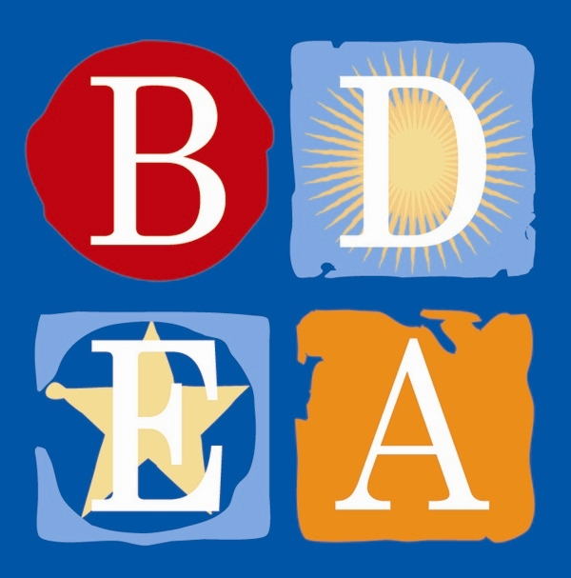

BOSTON DAY AND
EVENING ACADEMY
Sept. 20th, 2019

Dear BDEA Parent and Guardian,
The Special Education Parent Advisory Council, in collaboration with the Department of Elementary and Secondary Education will be hosting a parent orientation to learn about the upcoming Special Education and Civil Rights review in our district. The parent orientation will be held at Bolling Building, 2300 Washington Street, Roxbury, MA 02119 at 6:00 pm on Wednesday, October 23, 2019. Please join us!

You may contact Ms. Elisabeth (Lisa) Ewick at (617) 719-2771 or the school at (617) 635-6789 with questions about the parent orientation or the review. You may also find this information on our district website. Thank you.

**If you would like to attend and need translation, please contact Ms. Ewick at the number above.

Sincerely,

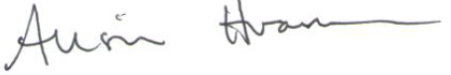

Alison Hramiec
Head of School
Boston Day and Evening Academy
W: 617-635-6789
Email: ahramiec@bostonpublicschools.org

